8th April 2019

**Splendid racing at FIA WTCR Race of Morocco**

The racing season in the FIA WTCR (World Touring Car Cup) series with Japanese premium manufacturer YOKOHAMA as Exclusive Tyre supplier began with the expected thrills, spills and excitement. Over the course of the weekend in Marrakech, three different drivers showed the resilience and ability to contest for the top spot in each race.

In race 1, Argentina’s Esteban Guerrieri scored the first win of 2019 in Morocco. The ALL-INKL.COM Münnich Honda Civic Type R TCR held off a challenge from fellow front row starter Thed Björk at Turn 1, then kept his lead throughout the 18-lap race, as just five seconds separated the top seven by the flag.

Björk’s Cyan Racing Lynk & Co 03 TCR pulled alongside the Honda at Turn 1 and even nosed ahead, but on the outside line of the long left-hander he was forced to cede.

“It was a nice race and I controlled the pace,” said Guerrieri. “Thed made a good start and we were side by side, but he was a gentleman. “I had some yellow lights flash up as an alarm, but after that everything was good. It’s great to start the season like this.”

Behind the top two, ALL-INKL.COM Münnich Motorsport’s Néstor Girolami couldn’t maintain his third place off the grid and lost out first to Cyan Performance Lynk & Co’s Andy Priaulx and then to Leopard Racing Team Audi Sport’s Jean-Karl Vernay.

Current Champion Gabriele Tarquini, took his BRC Hyundai N Squadra Corse i30 TCR to first place in the reverse-grid Race 2, whilst the Swede Björk, saved the best for last.

In race 3, driving a Lynk & Co 03 TCR developed by Chinese firm Geely Group Motorsport, Björk inherited first place from team-mate Yvan Muller and resisted intense pressure from pole-sitter Frédéric Vervisch to follow Esteban Guerrieri and Gabriele Tarquini as a winner.

“I am very happy and a little bit surprised to be on the pace,” said the 2017 FIA World Touring Car champion. “We did not know over the winter where we were, but obviously it’s indescribable to take a victory in the first weekend. Thed Bjork is now the leader at the top of the general table and making history for the Chinese team. Meanwhile the 2018 TCR Europe Champion Mikel Azcona from Spain, delighted himself and his team with a meritorious debut podium in the WTCR – FIA World Touring Car Cup presented by OSCARO achieved 3rd place. After the race Azcona, who is 22 and quit his job as a technician to focus on this first season at World level, expressed his happiness which was beyond his wildest expectations.

The FIA WTCR series will resume on 26-28 April at Hungaroring with the Race of Hungary.

Current Driver standings after first race weekend;

1 Thed Björk 61

2 Esteban Guerrieri 56

3 Gabriele Tarquini 49

4 Nestor Girolami 34

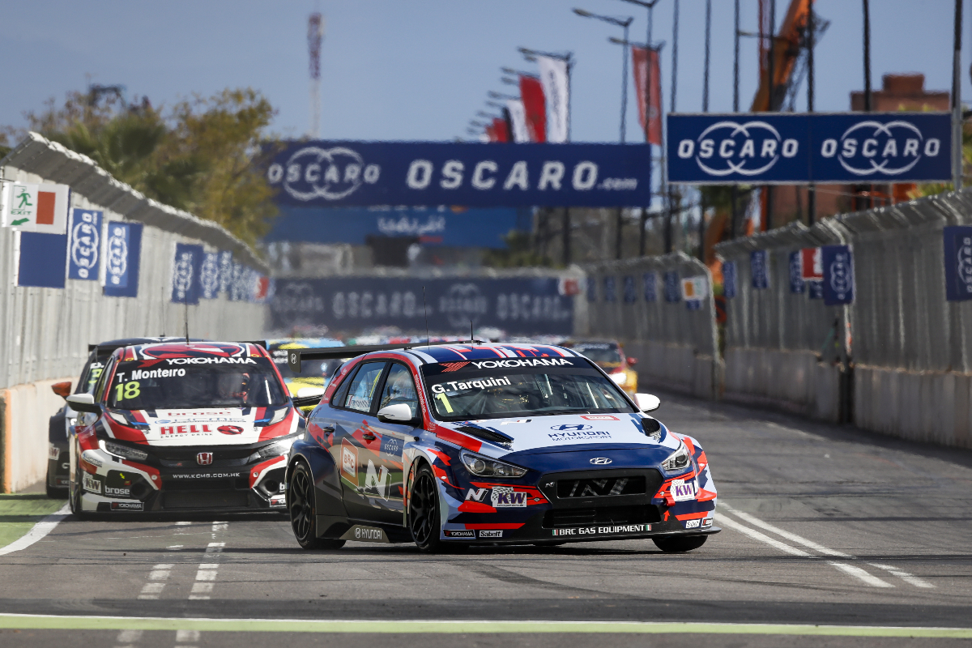

*2019 Tarquini Challenges again*

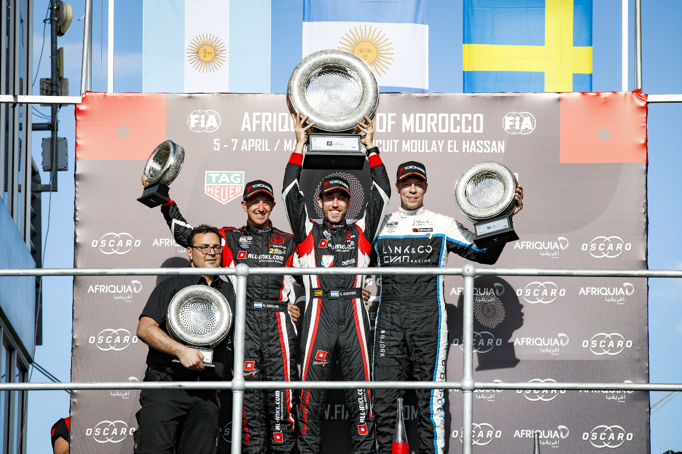

*Success for Girolami*